**CVD Risk Optimisation and Lipid**

**Lowering Therapy Guidelines**

**Index**

1. **CVD risk optimisation tool kit**
2. **Primary prevention of CVD**
3. **Secondary prevention of CVD**
4. **Statin intolerance**
5. **Monitoring on lipid lowering therapy**
6. **CVD lipid lowering therapy treatment targets**
7. **Special considerations with lipid lowering therapy**
8. **Familial Hypercholesterolaemia**
9. **Paediatric Familial Hypercholesterolaemia pathway**
10. **Hypertriglyceridaemia pathway**
11. **Referral criteria to lipid clinic**
12. **Electronic Referral Service**
13. **References**

**Appendices**

**Appendix A…………………………Primary Care Pathway for FH**

**Appendix B…………………………Primary CVD Prevention Pathway**

**Appendix C…………………………Secondary CVD Prevention Pathway**

**Appendix D………………………..Statin Intolerance Pathway**

**Appendix E…………………………Paediatric FH Pathway**

**Appendix F…………………………Hypertriglyceridaemia Pathway**

**CVD Risk Optimisation Tool Kit**

Treatment targets and goals for CVD prevention:

|  |  |
| --- | --- |
| **CVD Check List** | **Recommendation** |
| Document Family history of premature heart disease | Premature heart disease is defined as onset <60 years in first degree relatives and <50 years in second degree relatives |
| Does the patient have Familial Hypercholesterolaemia? | Refer to Simon Broome criteria & flow chart for Familial Hypercholesterolaemia – Appendix A (page 13)    NICE CG71: <https://www.nice.org.uk/guidance/cg71> |
| History of Chronic kidney disease? | Document stage of CKD, if applicable  <https://www.nice.org.uk/guidance/ng203> |
| Diabetes | Type 1: <https://www.nice.org.uk/guidance/ng17>  Type 2: <https://www.nice.org.uk/guidance/ng28>  Target HbA1c level of 53 mmol/mol |
| Smoking | Avoid exposure to tobacco in any form  https://www.nice.org.uk/guidance/ng209/  [Overview | Tobacco: preventing uptake, promoting quitting and treating dependence | Guidance | NICE](https://www.nice.org.uk/guidance/ng209/)  **Refer to stop smoking service locally in Hull** |
| Blood pressure | <https://www.nice.org.uk/guidance/ng136>  Target: <140/90 mm Hg (if primary prevention and not known to have documented hypertension, pregnancy, diabetes or chronic kidney disease).  Offer Ambulatory BP if clinic BP between 140/90 mmHg and 180/120 mmHg.  **Diabetes**:  In patients with type 1 Diabetes: target <135/85 mmHg  In patients with type 1 Diabetes and end organ involvement: target <130/80 mmHg  In patients with type 2 Diabetes**:** target <135/85 mmHg  **Chronic kidney disease**:  In adults with CKD and an ACR of >70 mg/mmol: target < 130/80 mmHg |
| Lipids | **Primary prevention of CVD**: Appendix B (page 14)  Target for High risk CVD (see list below) patients: **>40% reduction in Non- HDL-C from baseline**    **Secondary prevention of CVD**: Appendix C (page 15)  Target: **LDL-C goal of ≤ 1.8 mmol/L**    **Statin Intolerance pathway:** Appendix D (page 16) |
| Alcohol | <14 Units per week |
| Body weight | Healthy BMI 20- 25 kg/m2 and waist circumference <94 cm in men and <80 cm in women |
| Diet | Healthy well balanced diet with a low intake of saturated fat  Provide HEARTUK website information for heart healthy diet  [Eating for lower cholesterol | HEART UK - The Cholesterol Charity](https://www.heartuk.org.uk/low-cholesterol-foods/choose-low-cholesterol-foods) |
| Physical activity | Moderate intensity exercise minimum of 30 mins- 60 mins each day |

**Primary prevention of CVD**

* Request a full non-fasting Lipid profile for both diagnosis and monitoring patients with CVD risk.
* NICE CG181 recommends non HDL-c measured from a non-fasting blood in preference to LDL- c as the treatment goal for lipid lowering therapy. There are distinct advantages in using non-HDL cholesterol measurements (a fasting blood sample not needed, convenient for patients, cost effective. Non-HDL cholesterol includes all cholesterol present in lipoprotein particles considered to be atherogenic, (includes low-density lipoprotein (LDL), Lipoprotein (a), intermediate-density lipoprotein and very-low-density lipoprotein) and has been suggested to be a better tool for cardiovascular (CVD) risk assessment than LDL-c.
* Systemic conditions like Diabetes, Hypothyroidism, Obstructive liver disease, Nephrotic syndrome, Renal failure, Myeloma, pregnancy, medications(corticosteroids, Androgenic steroids, contraceptive therapy, Thiazides, non-selective β-blockers, Retinoic acid derivatives, HRT, sertraline, atypical antipsychotics, antiretroviral therapy), SLE, hypopituitarism may present with dyslipidaemia.
* Do a full secondary screen for dyslipidaemia (U&E, LFT, TSH, HbA1c, urine dipstick).
* Patients with Familial Hypercholesterolaemia, markedly elevated single risk factors, in particular TC ≥ 8 mmol/L and LDL-C ≥ 4.9 mmol/L or BP ≥180/110 mmHg, Diabetes with target organ damage (nephropathy) or a duration ≥ 10 years or another additional risk factor, patients with type 1 Diabetes > 40 years of age, Chronic kidney disease stage 3 A &B (eGFR 30-59 mL/min/1.73 m2) with or without albuminuria are at high CVD risk.
* Estimate CVD risk using QRISK3 algorithm <https://qrisk.org/three/> on adults aged up to 84 years of age.
* Document smoking status, diabetes status, family history of premature coronary artery disease, chronic kidney disease, therapy for hypertension, migraines, Systemic Lupus Erythematosus, regular glucocorticoid therapy, Rheumatoid arthritis, atrial fibrillation, atypical antipsychotics, erectile dysfunction, BMI and BP.
* **Do not use QRISK**:
  + Patients with Familial Hypercholesterolaemia or inherited disorders of lipid metabolism
  + Patients with established CVD
  + Patients with type 1 diabetes, or eGFR less than 60 mL/min/1.73 m2 and/or albuminuria.
  + Patients aged ≥ 85 (at increased risk of CVD because of age alone particularly people who smoke or have raised BP).
* Patients with CVD risk of ≥ 10% (QRISK-3) need an informed discussion to address modifiable risk factors including smoking cessation (if applicable), moderation of ethanol intake, low saturated fat intake in the diet and moderate physical activity (30-60 minutes each day). Use CVD risk tool (above) for further information.
* If a patient is being considered for lipid lowering treatment, ensure the drug is appropriate to the individual patient, especially in elderly patients with polypharmacy, multiple co-morbidities or in women of childbearing potential.
* If lifestyle modification is inappropriate or ineffective, commence Atorvastatin 20mg once daily. Counsel the patient that statin drugs are generally safe but, very rarely, they can cause muscle damage, so if they develop severe muscle aches or muscle weakness to discontinue all lipid-lowering drugs and seek medical advice.
* Review concordance with lipid lowering therapy, dietary, lifestyle changes and repeat lipid profile, and LFT’s in 3 months.
* Titrate lipid lowering therapy (**Atorvastatin to 40 mg once daily ± Ezetimibe 10mg daily)** to achieve Non-HDL C target of >40% reduction from baseline in all patients except for patients with Familial Hypercholesterolaemia. Assess further response after 3 months.
* For Patients with possible Familial Hypercholesterolaemia, consider referral to the Yorkshire and Humber FH service for FH genetic testing, if not done already.
* In patients with Familial Hypercholesterolaemia, LDL-C target is >50% reduction from baseline. Titrate **Atorvastatin to 40 mg once daily ± Ezetimibe 10mg daily**. Assess response after 3 months.
* In patients with Familial Hypercholesterolaemia, if LDL-C is ≥ 5mmol/L despite maximal tolerated lipid lowering therapy (statins ± Ezetimibe), refer to lipid clinic for consideration of **PCSK9 inhibitors**.
* Do not routinely measure CK activity unless the patients in symptomatic or has muscle pain before initiation of statin therapy.

**Secondary prevention of CVD**

* This category includes all patients with clinical Atherosclerosis e.g. Myocardial Infarction, Acute Coronary Syndrome, Angina, Stroke, Transient Ischaemic Attack, Peripheral Vascular Disease inclusive of revascularisation procedures, Abdominal aortic aneurysm including surgery.
* Start High intensity statins in all patients with Acute Coronary syndrome as early as possible, regardless of initial LDL-C values, unless there are any contraindications or intolerance.
* Consider addition of ezetimibe 10 mg once daily after repeat lipid profile in 2-3 months, in all patients with ACS not treated to **LDL-C target** **of ≤ 1.8 mmol/L**, despite maximal tolerated dose of statins.
* Refer to lipid clinic for **PCSK9 inhibitors** initiation **if:**
  + LDL –Cholesterol is persistently elevated ≥ 4mmol/L in patients at high risk of CVD and ≥ 3.5 mmol/L if at very high risk of CVD, despite maximal tolerated lipid lowering therapy (statins ± Ezetimibe).
  + High risk CVD is defined as a history of any of the following: acute coronary syndrome (such as myocardial infarction or unstable angina needing hospitalisation); coronary or other arterial revascularisation procedures; chronic heart disease; ischaemic stroke; peripheral arterial disease.
  + Very high risk of CVD is defined as recurrent cardiovascular events or cardiovascular events in more than 1 vascular bed (poly vascular disease).
  + Current lipid lowering therapy (statin ± Ezetimibe 10mg daily) should continue with PCSK9I therapy.
* Initiate **Inclisiran** if:
  + LDL-C ≥ 2.6 mmol/L (Non-HDL-C ≥ 3.5mmol/L), despite maximal tolerated lipid lowering therapy (statins ± Ezetimibe).
  + Current lipid lowering therapy (statin ± Ezetimibe 10mg daily) should continue with Inclisiran therapy
* Initiate **Icosapent ethyl** if:
  + Fasting triglycerides ≥1.7 mmol/L and <5.6 mmo/L on maximal tolerated statin therapy and if LDL is between 1 mmol/L and <2.6 mmol/L
  + Statin therapy should continue with Icosapent ethyl.
  + Icosapent ethyl is obtained from the oil of fish. It is not known whether patients with allergies to fish and/or shellfish are at increased risk of an allergic reaction to Icosapent ethyl. Icosapent ethyl should be used with caution in patients with known hypersensitivity to fish and/or shellfish. In patients with hepatic impairment, alanine aminotransferase (ALT) concentration should be monitored as clinically indicated before the start of treatment and at appropriate intervals during treatment. Icosapent ethyl was associated with an increased risk of atrial fibrillation or flutter requiring hospitalisation in a double-blind placebo-controlled trial. The incidence of atrial fibrillation was greater in patients with a previous history of atrial fibrillation or flutter. Patients, particularly those with a relevant medical history, should be monitored for clinical evidence of atrial fibrillation or atrial flutter (e.g., dyspnoea, palpitations, syncope/dizziness, chest discomfort, change in blood pressure, or irregular pulse). Electrocardiographic evaluation should be performed when clinically indicated. Treatment with Icosapent ethyl has been associated with an increased incidence of bleeding. Patients taking Icosapent ethyl along with antithrombotic agents, i.e., antiplatelet agents, including aspirin, clopidogrel and/or anticoagulants, may be at increased risk of bleeding and should be monitored periodically.

**Statin intolerance**

* In patients with intolerance or side effects to Atorvastatin therapy, see AAC Statin Intolerance Algorithm for advice regarding adverse effects.

<https://www.england.nhs.uk/aac/wp-content/uploads/sites/50/2020/08/Statin-Intolerance-Pathway-NEW.pdf>

* Consider Ezetimibe 10mg daily monotherapy (or in addition to maximal tolerated dose of statins). Assess response after 3 months.
* Consider referral to lipid clinic for initiation of **Bempedoic acid 180 mg daily** in combination with Ezetimibe 10 mg dailywhen ezetimibe monotherapy does not achieve treatment targets. Assess response after 3 months.
* In patients with Familial Hypercholesterolaemia for primary prevention of CVD, with statin intolerance, if LDL-C ≥ 5mmol/L, despite maximal tolerated lipid lowering therapy (statins ± Ezetimibe), consider referral to lipid clinic for **PCSK9 inhibitors initiation.**
* For secondary CVD prevention with statin intolerance, refer to lipid clinic for **PCSK9 inhibitors/Inclisiran** initiation if, LDL-C ≥ 2.6 mmol/L (Non-HDL-C ≥ 3.5mmol/L) despite maximal tolerated lipid lowering therapy (statins ± Ezetimibe).

**Monitoring on lipid lowering therapy**

|  |  |
| --- | --- |
| **Time** | **Investigations** |
| Baseline | Full lipid profile, U&E, LFT, TSH, HbA1c, urine dipstick |
| 3 months post statin initiation | Full lipid profile, LFT |
| 6-9 months, statin Rx up titration or addition of Ezetimibe | Full lipid profile, LFT |
| 12 months and then annually | Full lipid profile, LFT |

**CVD Lipid lowering treatment targets**

|  |  |  |
| --- | --- | --- |
| **Primary prevention of CVD** | Familial Hypercholesterolaemia | LDL-C target >50% reduction from baseline |
|  | Primary Non FH or mixed hyperlipidaemia | Non-HDL-C target >40% reduction from baseline |
| **Secondary prevention of CVD** |  | LDL-C target of ≤ 1.8 mmol/L or Non-HDL-C target of ≤ 2.5 mmol/L |

**Special considerations with lipid lowering therapy**

* A fully informed discussion is indicated in female patients in the reproductive age group prior to initiation of lipid lowering therapy inclusive of contraindications to lipid lowering therapy (Statins, ezetimibe, PCSK9I, Fibrates), need for screening children for Familial Hypercholesterolaemia (Autosomal dominant inheritance with 50% risk of inheritance) and risks to the foetus if lipid lowering therapy is continued.
* Patient who conceive on lipid lowering therapy should stop therapy immediately and be offered *urgent referral* for foetal assessment.
* In female patients with heterozygous Familial Hypercholesterolaemia, there is no indication to monitor lipid profile during pregnancy and breast feeding period.
* Annual review needs to take into account all CVD risk factors, treatment to target LDL-C/Non-HDL-C, concordance with lipid lowering therapy, diet and lifestyle. If applicable, a discussion on screening immediate family and conception plans is needed.
* For lipid lowering therapy initiation (or changes) in patients with chronic kidney disease with eGFR< 30mL/min, consider referral to lipid clinic.

|  |  |  |
| --- | --- | --- |
| Red drugs | Amber drugs | Green drugs |
| PCSK9 Inhibitors   * + Evolocumab   + Alirocumab   Bempedoic acid | Inclisiran  Icosapent ethyl | Statins  Ezetimibe  Fibrates |

**Familial Hypercholesterolaemia**

Familial Hypercholesterolaemia (FH) is an Autosomal dominant condition resulting in high LDL-cholesterol levels from birth with premature coronary heart disease (CHD) occurring in approximately half of men by age 50 and one third of women by age 60. Lifetime exposure to LDL-C correlates with increased risk of cardiovascular disease. The prevalence of heterozygous FH is 1 in 250. Early initiation of lipid lowering treatment combined with lifestyle modification can virtually eliminate any additional risk and potentially restore life expectancy to normal. The Yorkshire and Humber Familial Hypercholesterolaemia service identifies individuals with FH through genetic testing and offers cascade testing to family members where a pathogenic mutation has been identified. The Yorkshire and Humber Familial Hypercholesterolaemia service is based at 4 different Trusts including Huddersfield, Hull, Leeds and York and has a standardised FH genetic testing pathway for adults with FH with agreed local arrangements for the provision of Paediatric FH service. Refer to the primary care pathway for identification of patients with FH and primary and secondary CVD prevention pathway in the CVD risk optimisation tool kit for clinical management of FH. The FH service based at Hull University Teaching Hospitals NHS Trust offers extended service to the primary care networks in Hull, East Riding of Yorkshire, North Lincolnshire and North East Lincolnshire.

**Yorkshire and Humber FH Service contacts**

|  |  |
| --- | --- |
| **Site** | **Contact** |
| Calderdale & Huddersfield NHS Foundation Trust | Ms Jillian Webster, FH nurse specialist  Dr Karen Mitchell, Consultant Chemical Pathology |
| Hull University Teaching Hospitals NHS Trust | Ms Paula Sutton - FH nurse specialists  Ms Rachel Dunn- FH nurse specialist  Dr Deepa Narayanan- Consultant in Chemical Pathology & Metabolic Medicine  Dr Robert Desborough- Consultant in Chemical Pathology & Metabolic Medicine |
| Leeds Teaching NHS Hospitals Trust | Ms Claire Burton, FH nurse specialist  Dr Michael Mansfield, Consultant in diabetes and lipidology  Dr Kevin Stuart, Consultant Chemical Pathology & Metabolic Medicine |
| York Teaching Hospitals NHS Foundation Trust | Ms. Claire Tuson, FH nurse specialist  Dr Deepak Chandrajay, Consultant Chemical Pathology & Metabolic Medicine |

**Paediatric Familial Hypercholesterolaemia pathway**



**Hypertriglyceridaemia Pathway**



**Referral criteria to lipid clinic to HUTH**

* Initiation of PCSK9 Inhibitors/ Inclisiran/Bempedoic acid
* Not treated to LDLC targets despite maximal lipid lowering therapy
* Intolerance to 3 different statins
* Statin contraindication
* LFT abnormalities on statins
* Rhabdomyolysis on statins
* Possible Familial Hypercholesterolaemia
* Patients with triglyceride concentration ≥ 20 mmol/L or sustained triglyceride ≥10 mmol/L in the absence of known secondary causes of dyslipidaemia and history of pancreatitis

**Electronic referral service**

* **Choose and book service**

For lipid clinic/ FH service referrals, via ERS, select lipid/ Familial Hypercholesterolaemia service under Endocrinology.

* **Advice and guidance**

For advice and guidance queries regarding lipids or Familial Hypercholesterolaemia, via ERS, select lipid service under Endocrinology.

**References**

1. <https://www.nice.org.uk/guidance/cg71>
2. <https://www.nice.org.uk/guidance/cg181>
3. <https://www.nice.org.uk/guidance/ta394/chapter/1-Recommendations>
4. <https://www.nice.org.uk/guidance/ta393/chapter/1-Recommendations>
5. <https://www.nice.org.uk/guidance/ta694>
6. <https://www.nice.org.uk/guidance/ta733>
7. <https://www.england.nhs.uk/aac/wp-content/uploads/sites/50/2020/08/Statin-Intolerance-Pathway-NEW.pdf>
8. 2019 ESC/EAS Guidelines for the management of dyslipidaemias: lipid modification to reduce cardiovascular risk: The Task Force for the management of dyslipidaemias of the European Society of Cardiology (ESC) and European Atherosclerosis Society (EAS). <https://academic.oup.com/eurheartj/article/41/1/111/5556353>
9. <https://www.sunderlandccg.nhs.uk/wp-content/uploads/2021/07/Northern-England-Evaluation-and-Lipid-Intensification-Guideline-NEELI.pdf>
10. <https://www.england.nhs.uk/aac/wp-content/uploads/sites/50/2020/04/Lipid-Management-Pathway-NEW-version-4.pdf>

**Appendix**

**Appendix A: Primary Care Pathway for FH**



**Review family history of hyperlipidaemia and premature heart disease<60 yrs in first and <50 yrs in second degree relatives**

**Appendix B: Primary CVD Prevention Pathway**

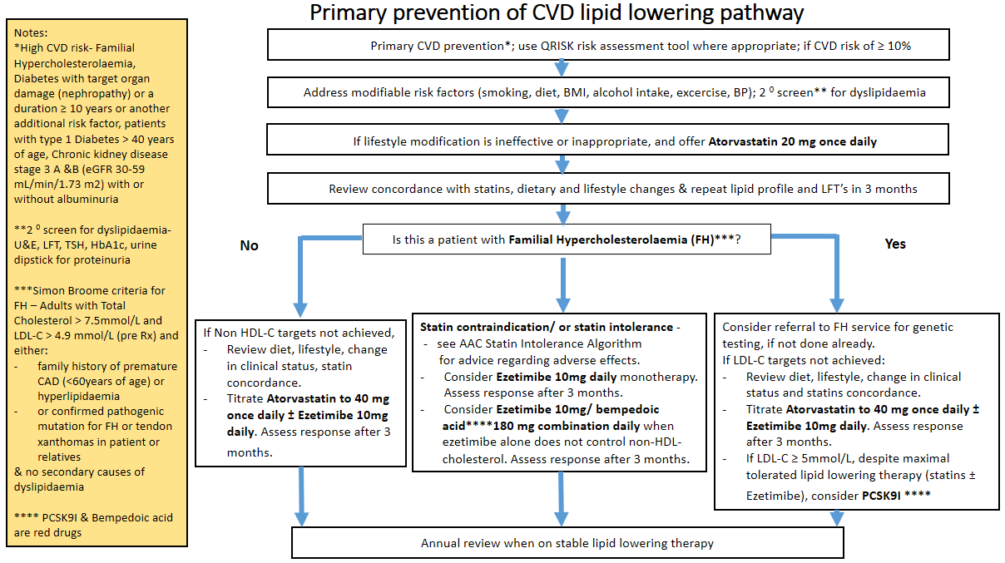

**Appendix C: Secondary CVD Prevention Pathway**

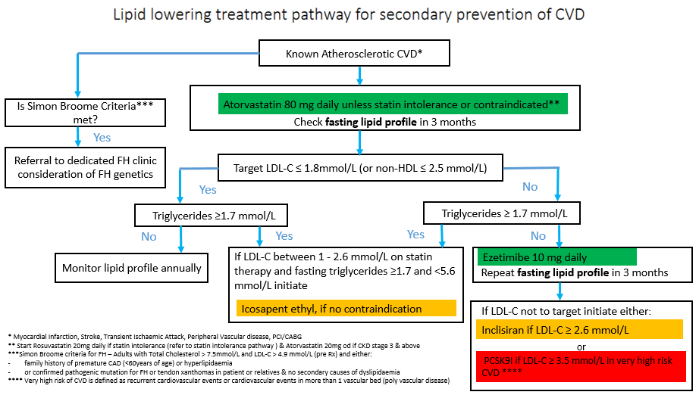

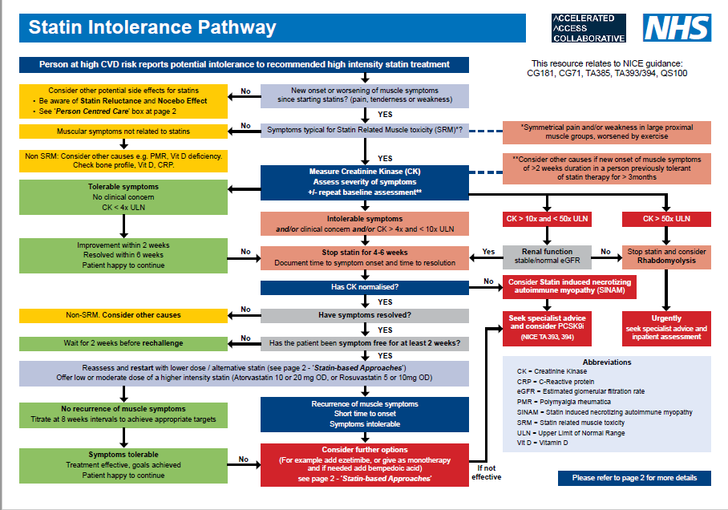

**Appendix D: Statin Intolerance Pathway**

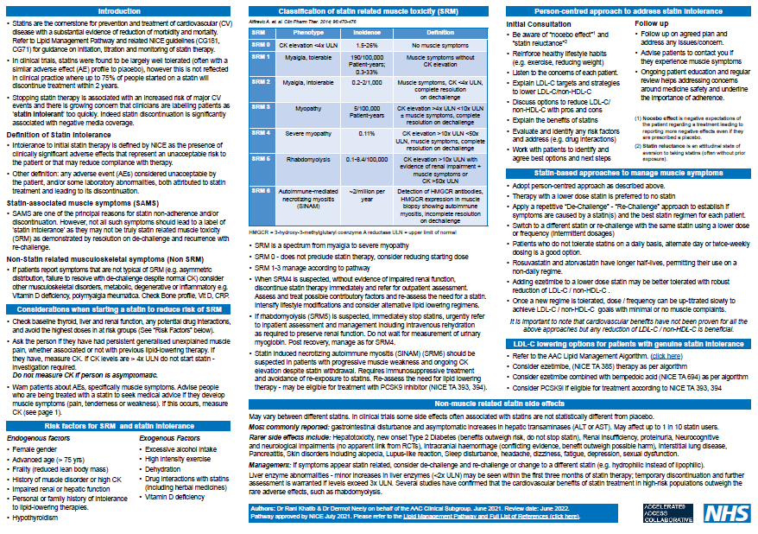

**Appendix E: Paediatric FH Pathway**

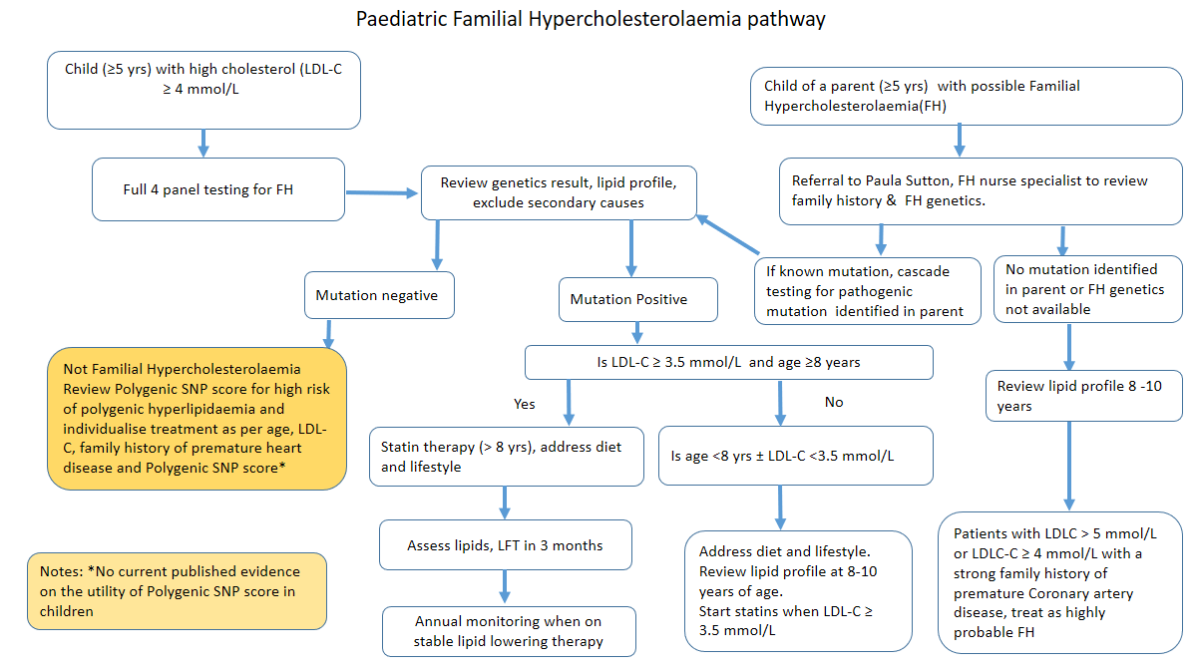

**Appendix F: Hypertriglyceridaemia Pathway**

